**Set Tayo Ng Date**

# “A tool for scheduling meetings in a group”

Submitted to:

Prof. Ma. Rowena C. Solamo

Faculty Member

Department of Computer Science

College of Engineering

University of the Philippines, Diliman

Submitted by:

Bandong, Arvin

Bariring, Edward James

Rosales, Kyle

In partial fulfillment of Academic Requirements for the course

CS 191 Software Engineering I of the

1st Semester, AY 2016-2017

***Unique Reference:***

The documents are stored in the <https://github.com/DarkPotatoKing/cs-191-192-repo>

***Document Purpose:***

This document serves as the blueprint of the project and to let it’s reader know what to expect on the software.

***Target Audience:***

Target audience for this software is primarily students that needs to meet as a group while having different schedules.

***Revision Control:***

|  |  |  |  |
| --- | --- | --- | --- |
| ***Revision***  ***Date*** | ***Person Responsible*** | ***Version*** ***Number*** | ***Modification*** |
| 09/07/16 | Kyle Rosales | 1.0 | Initial Document |
| 09/14/16 | Edward James  Bariring | 1.1 | Added Header and Footer |
| 9/24/16 | Edward James Bariring | 1.2 | Fixed typographical errors |

|  |  |
| --- | --- |
| *Project Title*: | Set Tayo Ng Date |
| *Description*: | This software allows people in a group to input their schedules into the software's database. It is a tool to help people set meetings when everyone in the group is free by displaying everyone's schedules. It also has advance search options which lets you answer questions like "When is Alice, Bob, and Charlie free between 10 am and 2 pm? |

*Context Diagram*:

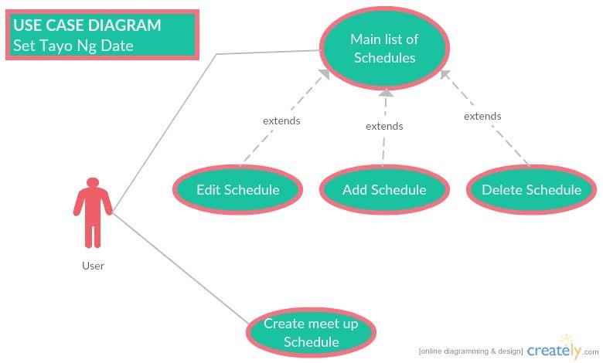

*Entities*:

User - any person such as a group leader or a project manager who is using the software to set a schedule between the group.

Major Inputs:

Schedules of people – Timeframe when each person is busy

Major Outputs:

Schedule table – a table of all the possible times where all of the people to meet are free

Major Functionalities:

Manage schedules - allows adding, deleting, and modifying schedules of anyone in the group

View - view schedules of everyone in the group

Search - search for a free time subject to certain constraints (like which people, between what time, etc.)